ECE 465 Lab 1
Introduction to Circuitverse and Review of Circuits
- Introduction
The purpose of this lab is for individuals to review logic gates along with the introduction to the online web program circuit verse.

- Creating a Circuit
Start by going to circuitverse.org. In doing so you will be greeted the workspace.
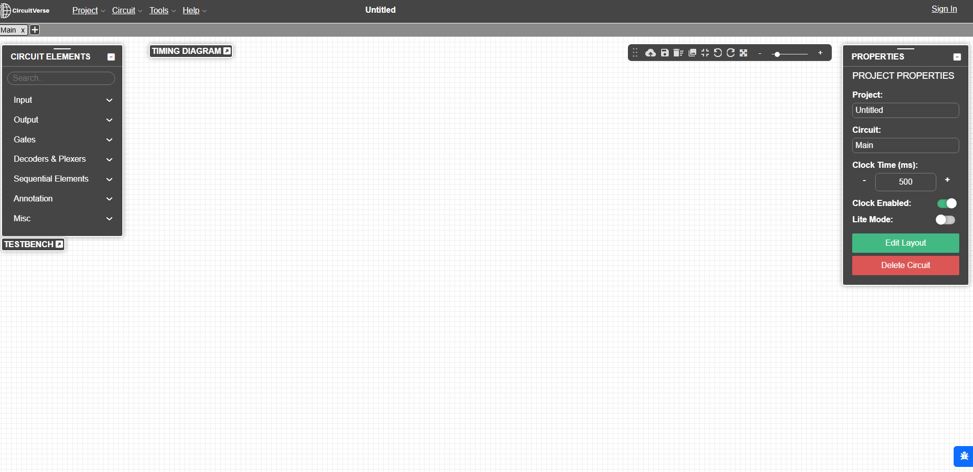
There’s a menu of circuit elements that you can choose from. Start by choosing the Input menu, then selecting the toggle element.
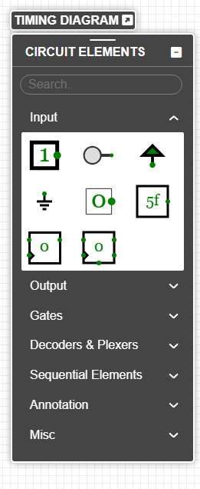
You can drag and drop the input element on to the workspace. When selecting the input element, you’ll be greeted with a properties menu that looks as so. Label each input A and B.
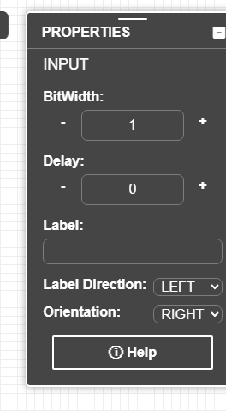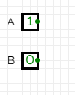
Under Circuit Elements, navigate to the gates menu. We’re going to create a half adder. From the menu, select the and and Xor Gate. Gates also receive a properties menu, and for organizational sake, label the respective gates. The wiring can be dragged from the input to the respective gate.
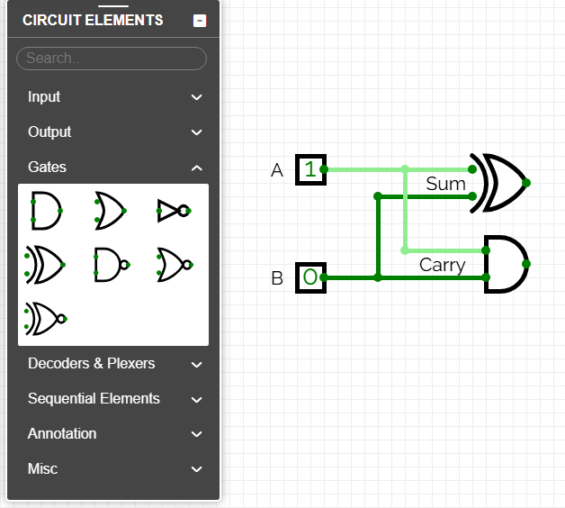
Finally, go to the output menu in circuit elements, and select the first option which is also named output.
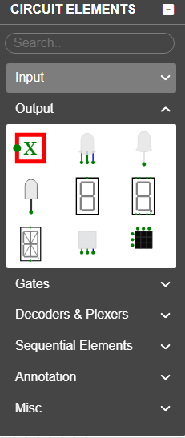
Follow the same logic of dragging the wiring to the output, and in doing so you’ll have created your first circuitverse circuit!
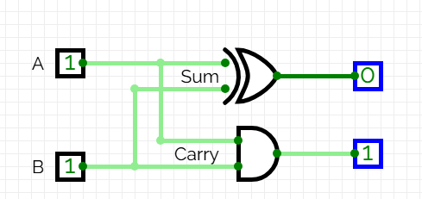
- Creating a full adder
Now, with the example, it’s time to create a full-adder. Use what you know to create a full adder. The TA will check you off for this part once you’ve make a full-adder.

- Creating a Custom Circuit
Finally, you will be creating a 4-bit adder. At first, this may sound messy but circuitverse has a feature where you can save your circuit designs and use them in larger designs. It is also crucial that you label your inputs and outputs as they will appear on the circuit block.
In the top menu, hit the plus icon to create a new circuit. 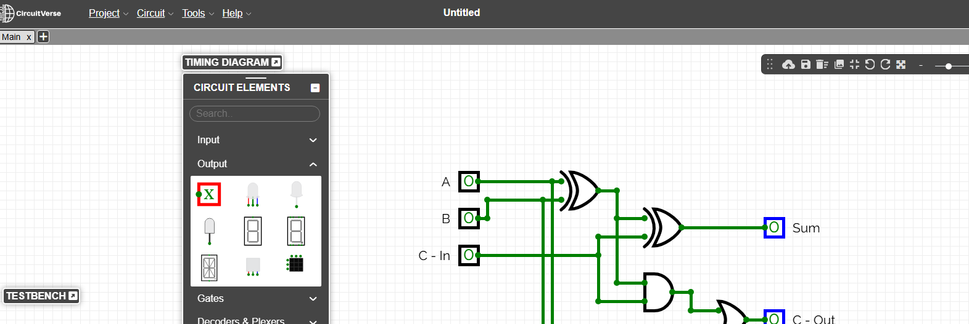
Name it Full-Adder. From the main tab, shift click and drag selecting your entire circuit. Crtl-C and Crtl-v in the new circuit. In the main circuit, right click and select Insert SubCircuit. Then Select Full Adder
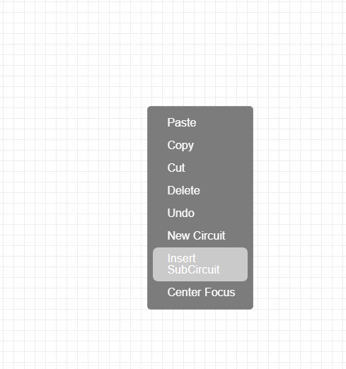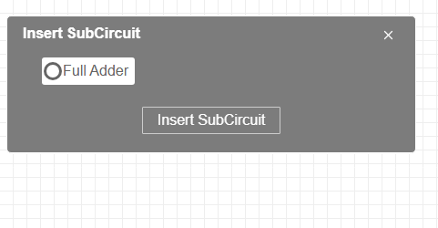
You’ll have the Full Adder Block in your main Circuit. 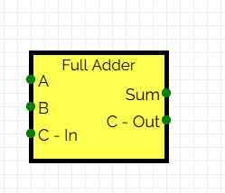
Finally, now create a 4 bit adder using your full adder circuits.

